Faces in the wild

Test loss: 2.28725702249

Test accuracy: 0.496368038091

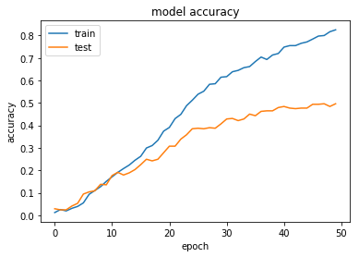

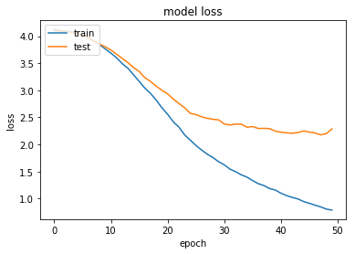

_________________________________________________________________

Layer (type) Output Shape Param #

=================================================================

conv2d_1 (Conv2D) (None, 84, 62, 32) 544

_________________________________________________________________

max_pooling2d_1 (MaxPooling2 (None, 42, 31, 32) 0

_________________________________________________________________

conv2d_2 (Conv2D) (None, 39, 28, 64) 32832

_________________________________________________________________

max_pooling2d_2 (MaxPooling2 (None, 19, 14, 64) 0

_________________________________________________________________

flatten_1 (Flatten) (None, 17024) 0

_________________________________________________________________

dense_1 (Dense) (None, 128) 2179200

_________________________________________________________________

dense_2 (Dense) (None, 62) 7998

=================================================================

Total params: 2,220,574

Trainable params: 2,220,574

Non-trainable params: 0

_________________________________________________________________

Faces in the wild, synthetic data added

Test loss: 2.28725702249

Test accuracy: 0.496368038091

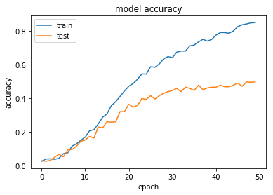

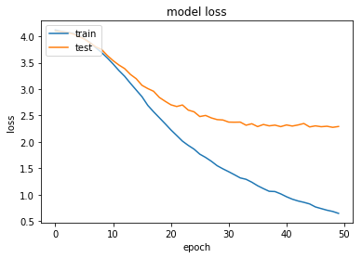

_________________________________________________________________

Layer (type) Output Shape Param #

=================================================================

conv2d_3 (Conv2D) (None, 84, 62, 32) 544

_________________________________________________________________

max_pooling2d_3 (MaxPooling2 (None, 42, 31, 32) 0

_________________________________________________________________

conv2d_4 (Conv2D) (None, 39, 28, 64) 32832

_________________________________________________________________

max_pooling2d_4 (MaxPooling2 (None, 19, 14, 64) 0

_________________________________________________________________

flatten_2 (Flatten) (None, 17024) 0

_________________________________________________________________

dense_3 (Dense) (None, 128) 2179200

_________________________________________________________________

dense_4 (Dense) (None, 62) 7998

=================================================================

Total params: 2,220,574

Trainable params: 2,220,574

Non-trainable params: 0

Molecule Dataset

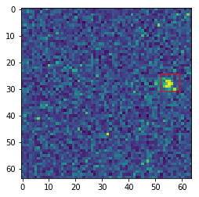

0.981198

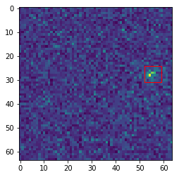

0.797373

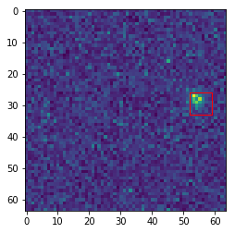

0.999982

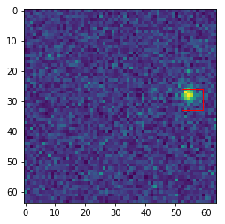

0.999969

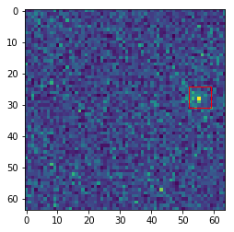

0.0493994

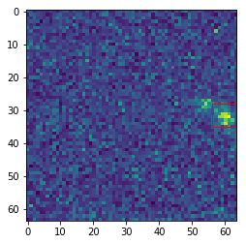

0.99156

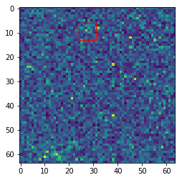

0.0163845

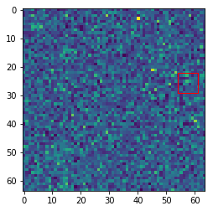

0.0160653

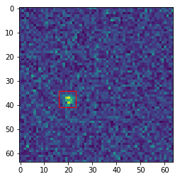

0.999466

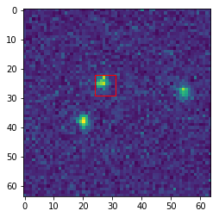

1.0

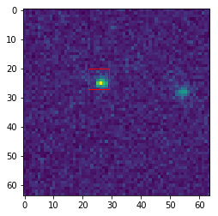

1.0

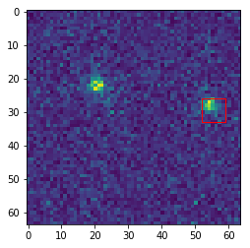

1.0

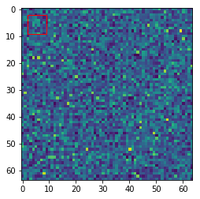

0.0165014

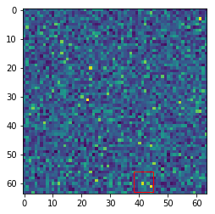

0.0209529

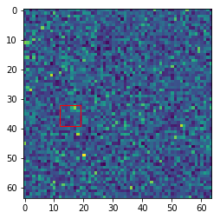

0.0083394

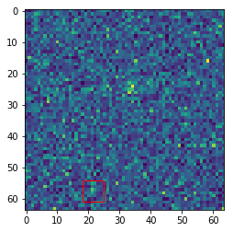

0.0105515

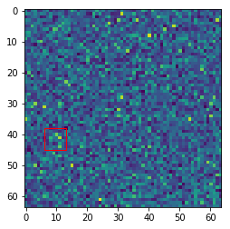

0.0140879

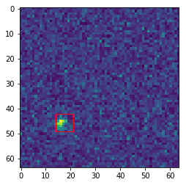

0.999997

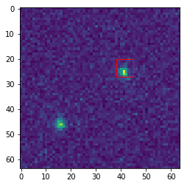

1.0

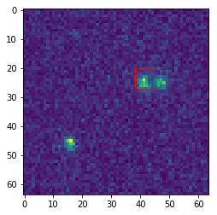

1.0

Test loss: 0.1332694155

Test accuracy: 0.958700293568

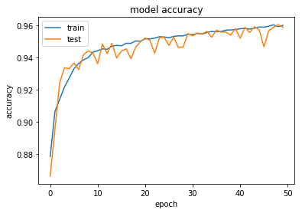

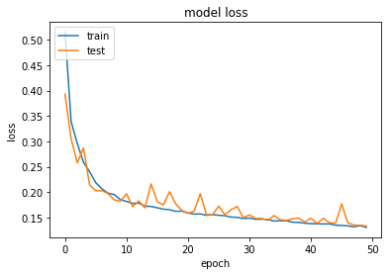

_________________________________________________________________

Layer (type) Output Shape Param #

=================================================================

conv2d_1 (Conv2D) (None, 6, 6, 32) 160

_________________________________________________________________

max_pooling2d_1 (MaxPooling2 (None, 3, 3, 32) 0

_________________________________________________________________

conv2d_2 (Conv2D) (None, 2, 2, 64) 8256

_________________________________________________________________

max_pooling2d_2 (MaxPooling2 (None, 1, 1, 64) 0

_________________________________________________________________

flatten_1 (Flatten) (None, 64) 0

_________________________________________________________________

dense_1 (Dense) (None, 128) 8320

_________________________________________________________________

dense_2 (Dense) (None, 2) 258

=================================================================

Total params: 16,994

Trainable params: 16,994

Non-trainable params: 0

_________________________________________________________________